Uniform Options

Logo Options for Tops – can be embroidered in solid black, green, gold, or white thread

Tops and bottoms can be solid black, white, cream, khaki, or a shade of gray.



Land’s End

https://www.landsend.com/products/school-uniform-girls-pleated-skort-top-of-knee/id_364663?attributes=1242,43388,44256,44257,45133,52957 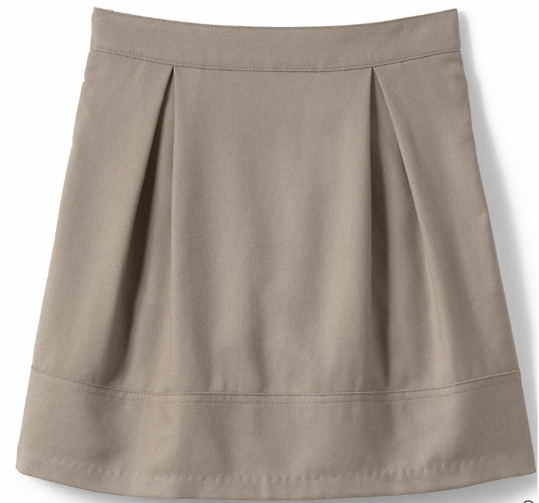

https://www.landsend.com/products/school-uniform-girls-blend-chino-skort-top-of-knee/id_364632?attributes=1242,43388,44256,44257,45133,48354,52957

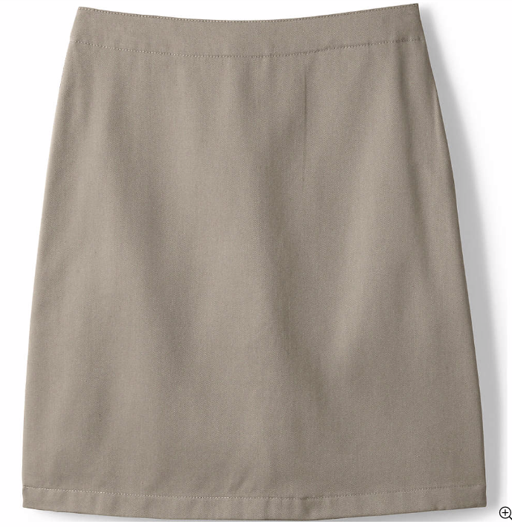
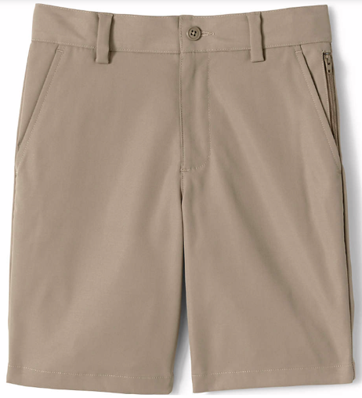
https://www.landsend.com/products/school-uniform-boys-active-chino-shorts/id_364696?attributes=1242,43307,43323,43387,45133,48354,52957

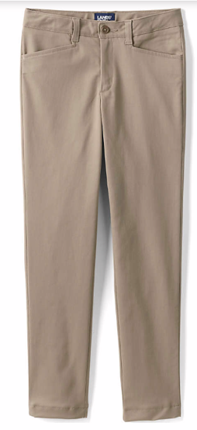
https://www.landsend.com/products/school-uniform-girls-stretch-pencil-pants/id_364658?attributes=1242,43385,44860,45133,52957

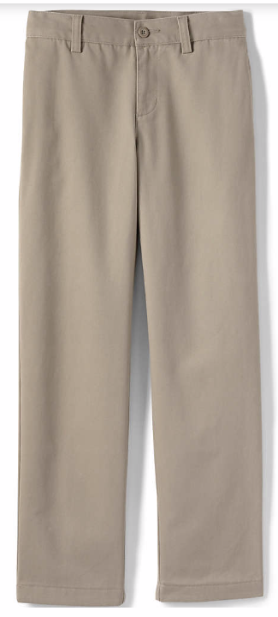
https://www.landsend.com/products/school-uniform-boys-iron-knee-wrinkle-resistant-plain-front-chino-pants/id_364687?attributes=1242,43385,44860,45133,48354,52957

https://www.landsend.com/products/school-uniform-short-sleeve-rapid-dry-polo-shirt/id_364707?attributes=2573,44250,45022,45133,52957
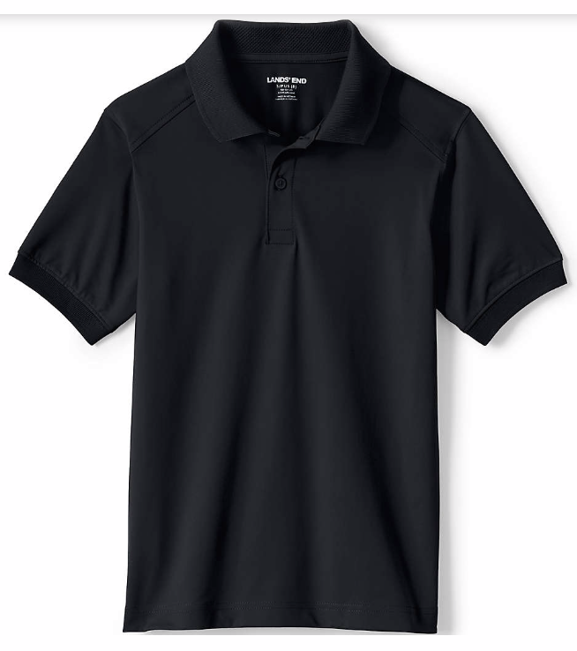 Black or white shirt
Long or short sleeve

https://www.landsend.com/products/school-uniform-girls-short-sleeve-peter-pan-collar-polo-shirt/id_364647?attributes=32671,45022,45133,52957
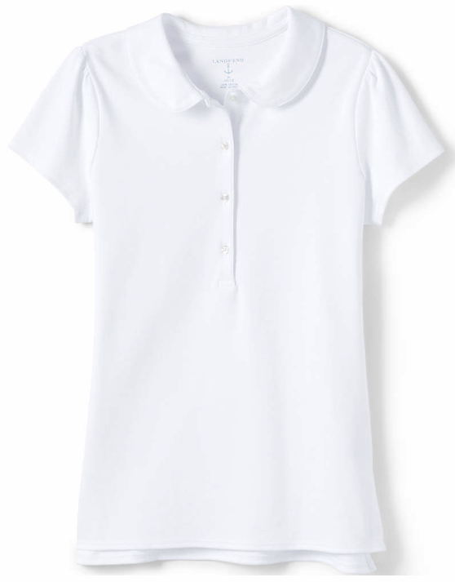White only option
Long or short-sleeved

https://www.landsend.com/products/school-uniform-girls-short-sleeve-feminine-fit-interlock-polo-shirt/id_364627?attributes=6199,45022,45133,52957
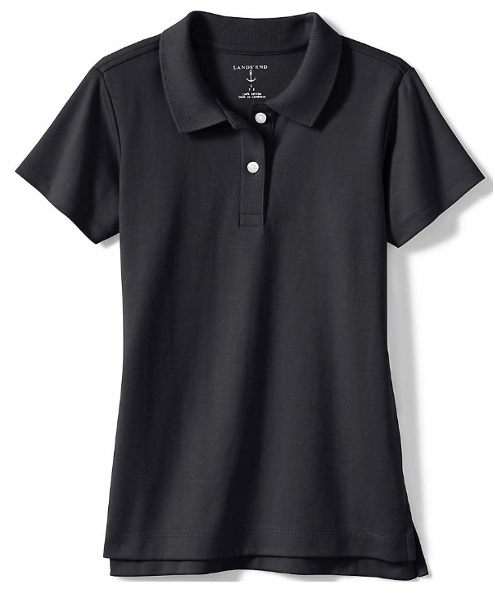Black or white option
Long or short-sleeved

https://www.landsend.com/products/school-uniform-girls-ponte-pleat-jumper-top-of-knee/id_364656?attributes=12323,43307,43324,44256,44257,45133
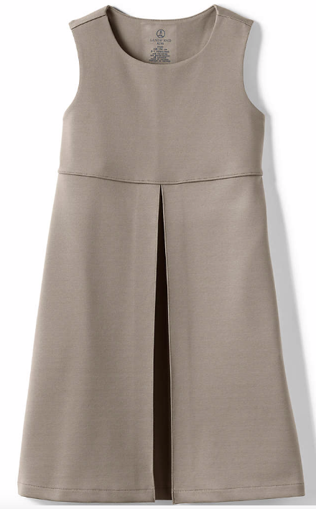
https://www.landsend.com/products/school-uniform-full-zip-mid-weight-fleece-jacket/id_364610?attributes=12341,43326,44250,44257,44258,45133,52957
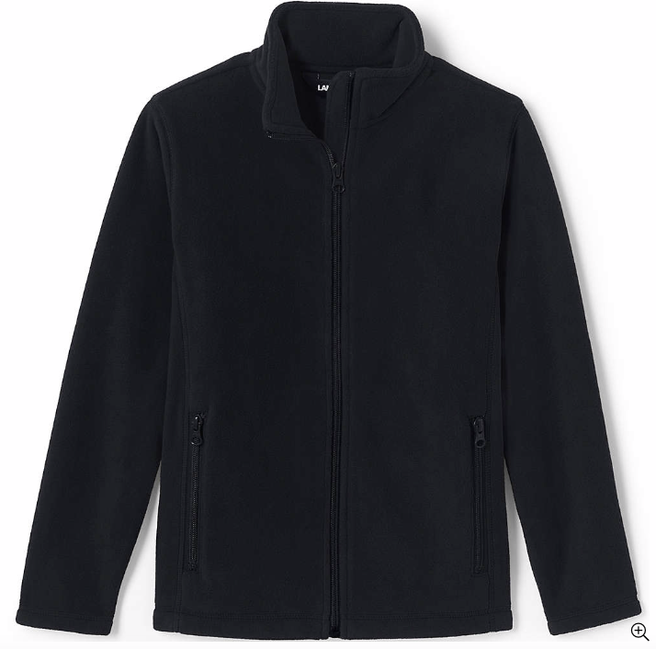

Sanmar

https://www.sanmar.com/p/1664_Black#?doScrollToGrid=true
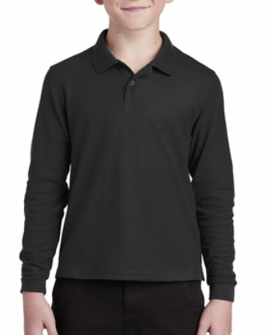Black or white option
Long or short-sleeved

https://www.sanmar.com/p/7267_Black#?doScrollToGrid=true
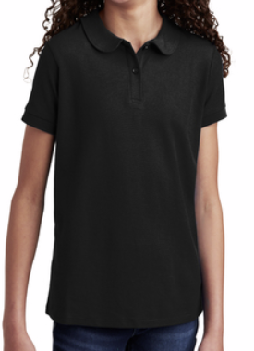Black or white option

https://www.sanmar.com/p/31873_Navy#?doScrollToGrid=true
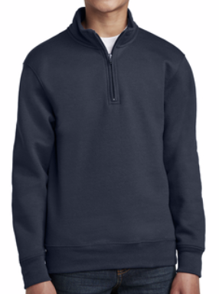

https://www.sanmar.com/p/5727_Black#?doScrollToGrid=true
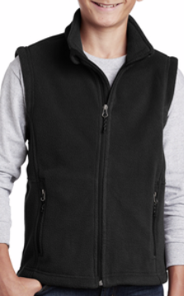

Swag for Spirit Store
(can do biannual presale as fundraiser)

https://www.sanmar.com/p/6739_Black
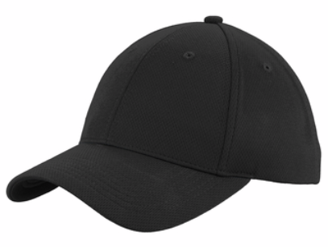

Tervis Tumblers and/or stainless steel tumbler
Lunchboxes
Magnets with school calendar for open house
Pennant
Hairbows
Hats (youth and adult)
Stickers
Vehicle window stickers
Pens
Notebooks
Comfort Color sweatshirts
Comfort Color tshirts
Backpacks
Pencils
Totes

Logo Options for Promo Products



